**Time Machine (Easy)**

**Get into a time machine, find out some information about a day in the past.**

**What was the day's high temperature (in °F) at San Francisco International Airport on 2010-06-30?**

* Go to “TimeandDate.com.”
* Click “Weather” in the top black tab bar.
* Search “San Francisco” in the top right search bar.
* Select “Yesterday/Past Weather.”
* Select June 2010.
* Look through weather log.
* Answer: 65

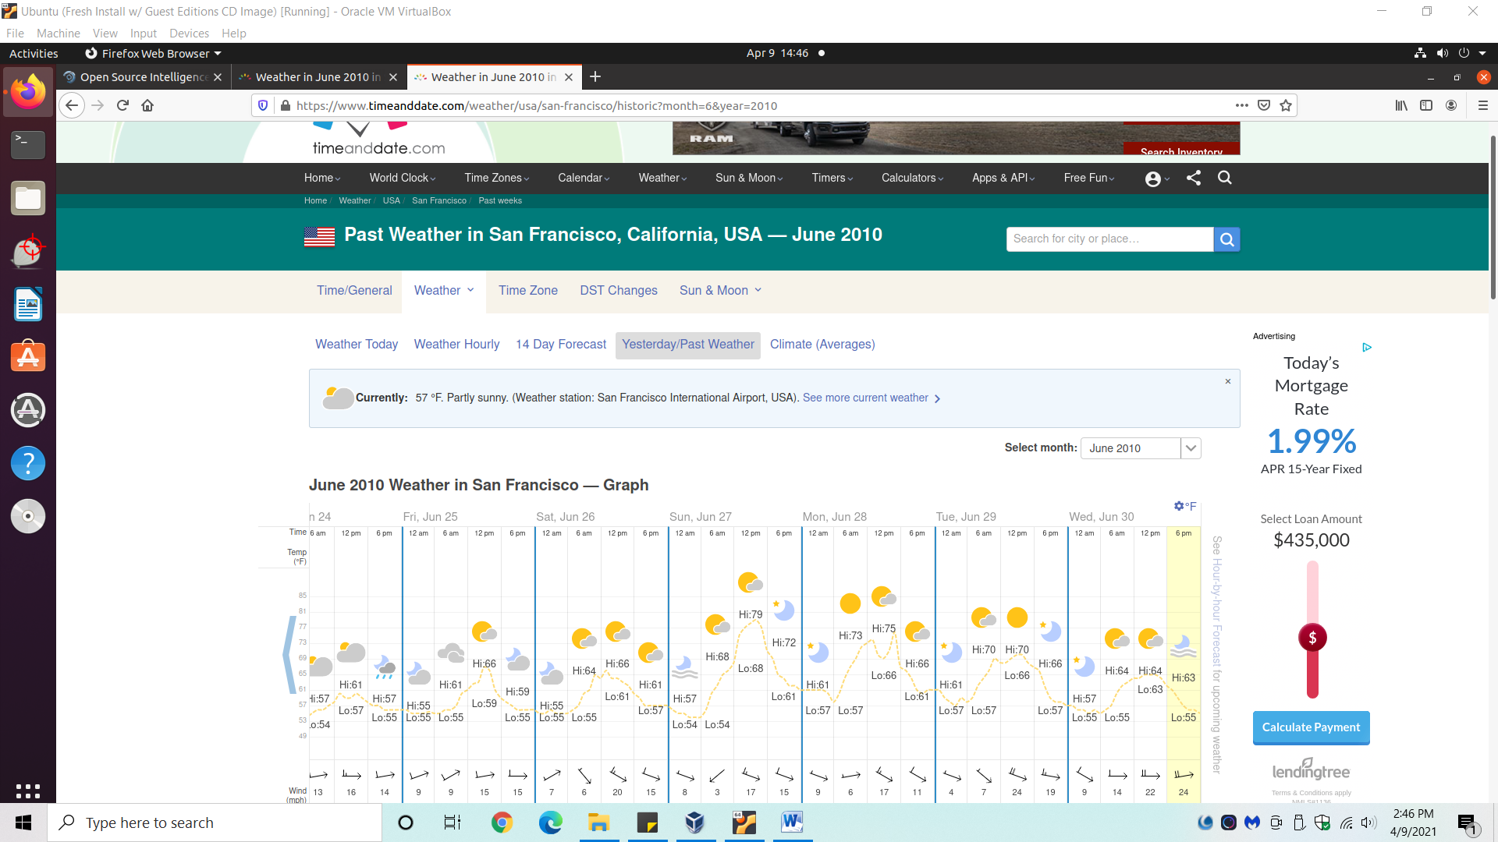

**What country's national park was featured by Bing on 2015-07-01?**

* Google the question and the 1st or 2nd webpage should be about Banff National Park, Alberta, Canada.
* Answer: Canada

**What was the Merriam-Webster Word of the Day on 2017-08-25?**

* Google the question.
* Answer: Picaresque